Student Reading List by Theme: HOME SWEET HOME
Mrs. Larson Week of June 15th
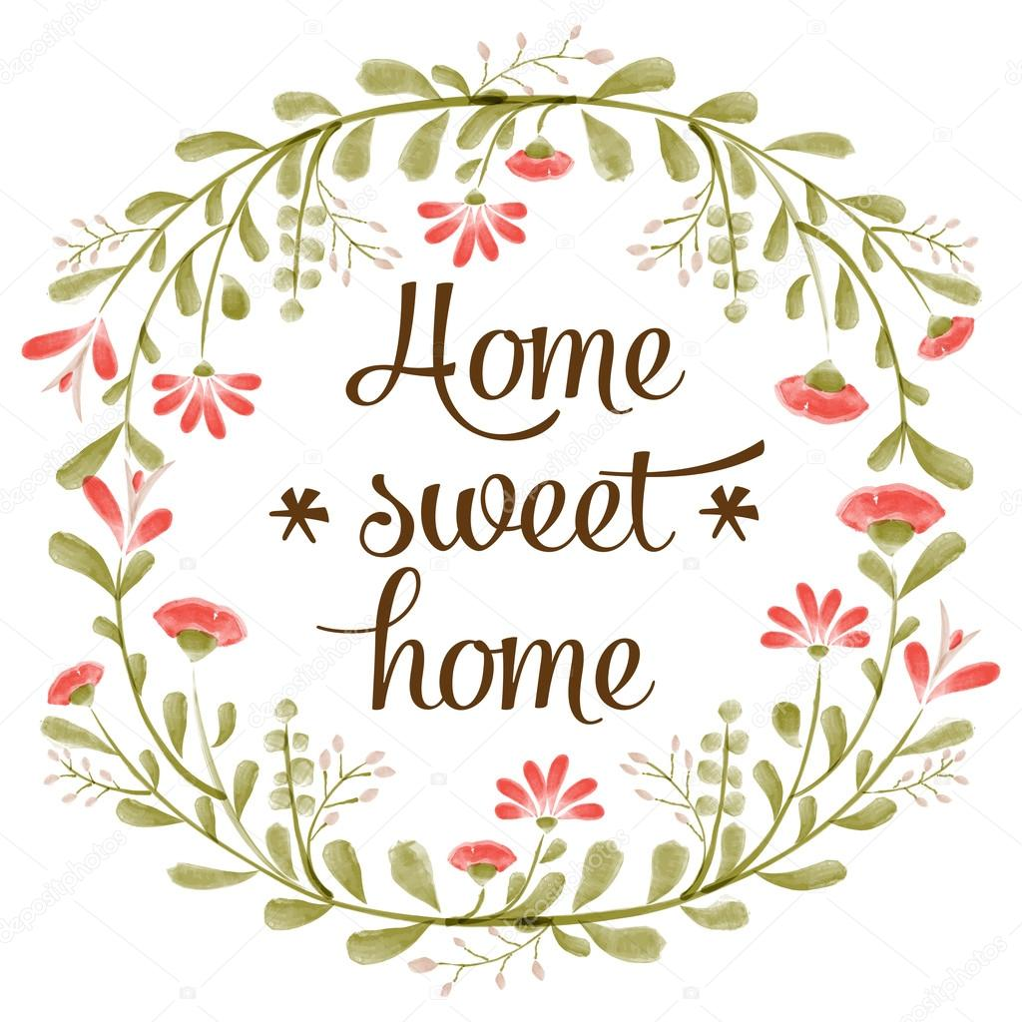
Hello Grade 8 & 9 English Students,
This week’s theme is HOME SWEET HOME. I have included links to articles below for you to continue your daily reading practice and to help with inspiration for your weekly challenge around this theme. This reading list is NOT mandatory reading. It is meant to offer a menu of items for you to choose from to help guide your reading and writing practice this week.
I have also included a vocabulary concept map for the vocabulary word: BIAS. We all carry biases based on our background and experiences. As you reflect this week on your home and where you come from, think about the lens with which you see the world. What are your biases?
As a reminder, check out my Literacy@MSS webpage for more resources to support reading and writing practice at home. Also, if you want any eBooks or library books to read at home, please email me and I will do my best to find it for you!
https://mss.sd58.bc.ca/literacymss/
Happy Reading,
Lia Larson
Teacher-Librarian
Merritt Secondary School
llarson@365.sd58.bc.ca

Week 10 Reading List: HOME SWEET HOME
- MERRITT HISTORY

Description: Check out the links below for articles about the history of Merritt & the Nicola Valley from different perspectives:

  - Title: History of Merritt
Source: Tourism Merritt
Link: https://www.tourismmerritt.ca/merritt/history

  - Title: Historical Sites
Source: Merritt.ca (City of Merritt website)
Link: https://www.merritt.ca/discover-merritt/historical-sites

  - Title: History in Merritt, BC, Canada
Source: Experience Nicola Valley (blog article by Traci Marie)
Link: https://experiencenicolavalley.com/merritt-bc-history/

  - Title: The History of Quilchena Ranch
Source: Douglas Lake Cattle Company
Link: https://www.douglaslake.com/history-quilchena

  - Article Title: First Nation Traditional Foods and Lodging in the Nicola Valley
Source: Experience Nicola Valley (blog article by Gerome Garcia)
Link: https://experiencenicolavalley.com/nicola-valley-traditional-foods-and-lodging/

  - Article Title: Canadian History/The People of the Lands/Okanagan
Source: wikibooks.org
Link:https://en.wikibooks.org/wiki/Canadian_History/The_People_of_the_Lands/Okanagon

Questions to guide your reading: This week’s theme is all about home, so I thought we could explore the history of our area. When did your family settle in the Nicola Valley or have they always been here? Do you consider Merritt & the Nicola Valley home? Why or why not?
- FAVOURITE CAMPING SPOTS
Article Title: Camping in Merritt BC and the Nicola Valley
Source: Experience Nicola Valley (blog article by Tom Reynolds)
Link: https://experiencenicolavalley.com/camping-in-merritt-bc-and-the-nicola-valley/
Description: Short article about one blogger’s favorite spot to go camping around Merritt!
Questions to guide your reading: What is your favorite spot to go camping or spend time outdoors around Merritt?

- HOMES AROUND THE WORLD

Title: 15 Traditional Housing Types from Around the World

Source: World Atlas
Link: https://www.worldatlas.com/articles/15-traditional-house-types-from-around-the-world.html
Description: A medium length article with images that explores the different types of houses built in different countries around the world.

Questions to guide your reading: Have you ever seen any of the traditional homes shown in this article? Are you aware of any traditional homes in your culture? Which is your favorite traditional house from the article?

- CRAZY & STRANGE HOMES

Title: 10 Of the Most Unusual Homes in the World

Source: Bored Panda
Link: https://www.boredpanda.com/unusual-homes/?utm_source=bing&utm_medium=organic&utm_campaign=organic
Description: A short article that shows homes that were built by architects/owners who think outside of the box!

Questions to guide your reading: Which house would you like to live in the most and why?
- POETRY

Title: 10 of the Best Poems about Houses and Homes

Source: InterestingLiterature.com
Link: https://interestingliterature.com/2017/06/10-of-the-best-poems-about-houses-and-homes/
Description: A medium length article that shares “ten of the finest poems about houses and homes – from the humblest abodes to the stately homes of England.” You can click on many of the poem titles to read the full poems.

Questions to guide your reading: Do you have a favorite poem or song that talks about or reminds you of home?

- PSYCHOLOGY
Title: Home Is Where the Heart Is, but Where Is "Home"?
Source: Psychology Toady
Link: https://www.psychologytoday.com/us/blog/out-the-ooze/201508/home-is-where-the-heart-is-where-is-home
Description: A medium length article that looks at the psychology of the emotional attachments we make to our “home” or the “place in our heart” that we call home.
Questions to guide your reading: The author of the article states, “As you reflect upon where your home is, ask yourself why this particular place out of the many places that you may have lived stands out as the one that feels like home. By doing so, you may also gain a deeper understanding of how you think about yourself and your connection with the world at large.”

